# Question 1D:

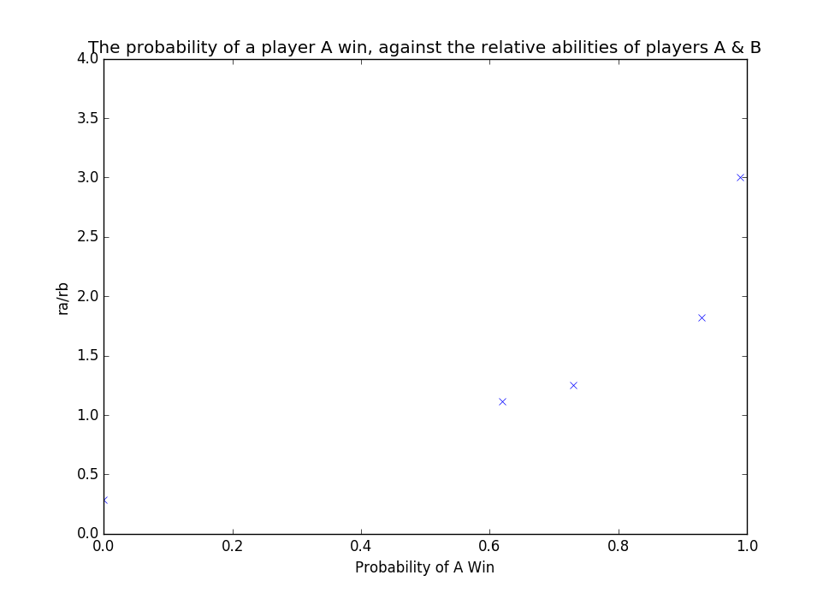

# Question 2:

# Transcript:

